COMPLETED WORK ON PC OR LAPTOP USING WORD OR POWERPOINT.
1. Save your work in a place where you can locate it.
2. Log on to Google Classroom.
3. Click on assignment that the work if for - for example Maths
4. On the righthand screen there is a button that saves add/create.
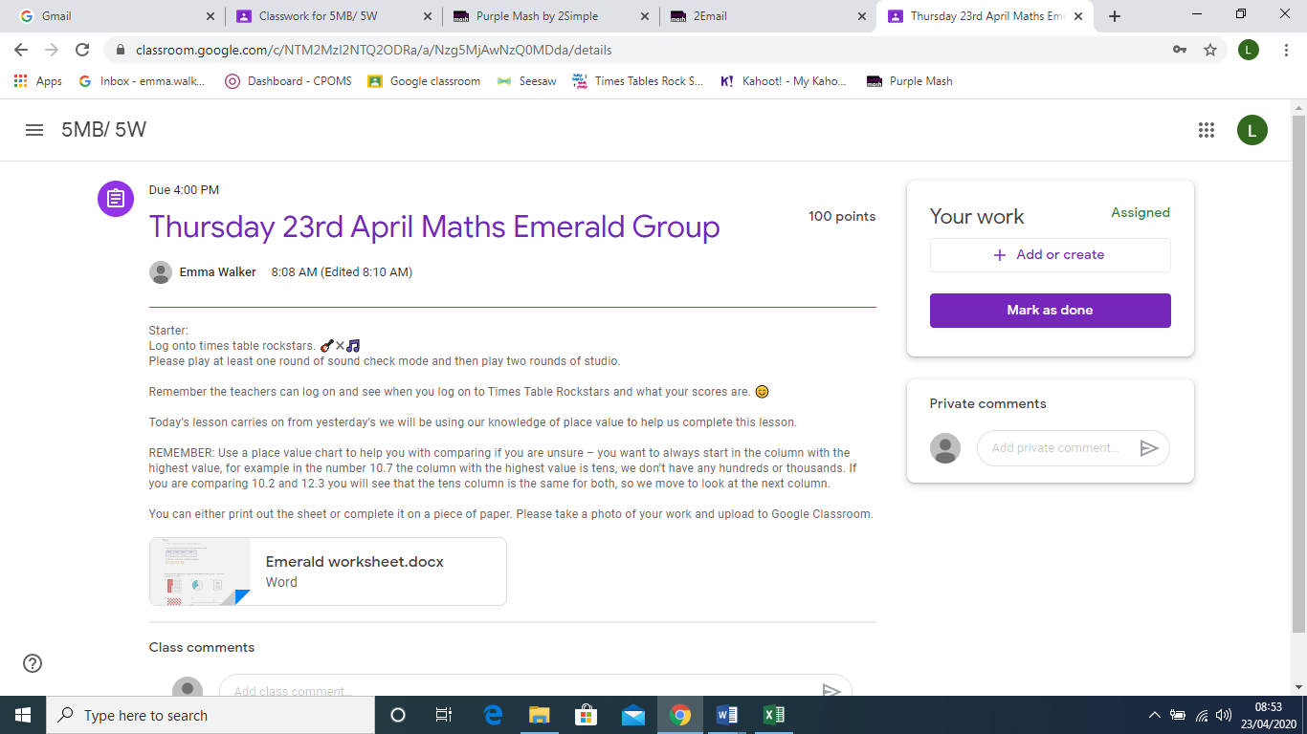

5. Click on file.
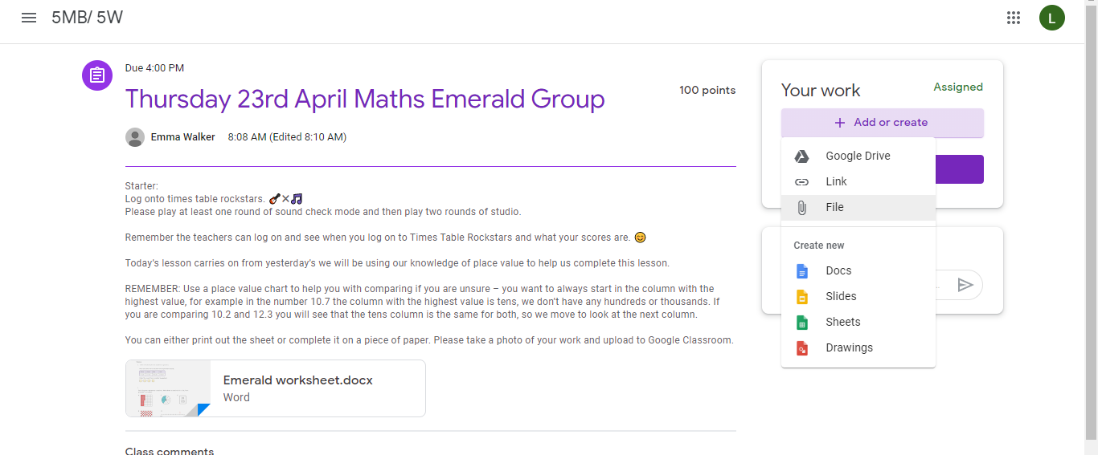

6. It will then look like this.

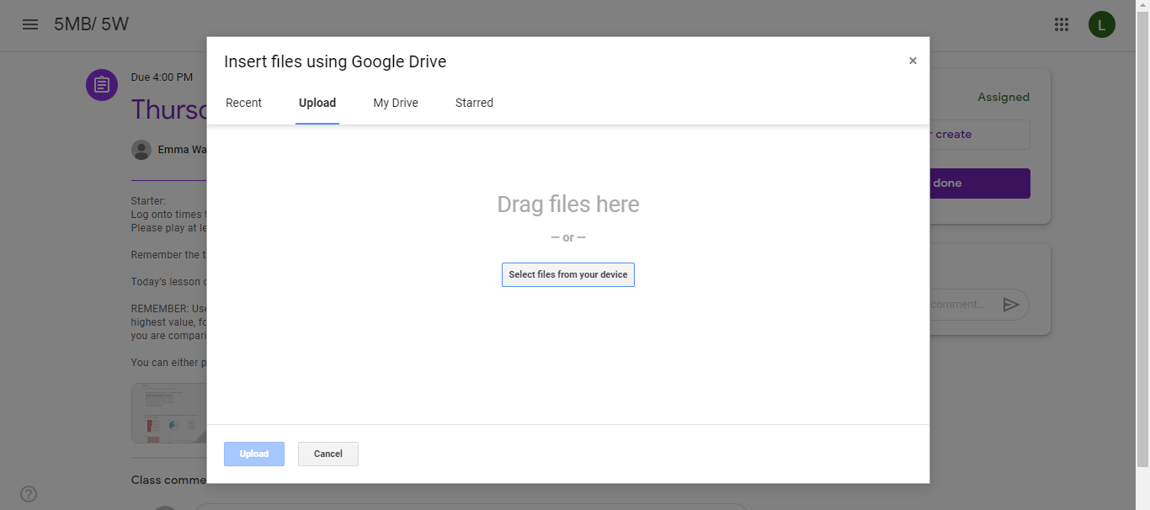
7. Click on select files from your device. This will give you the option to go to the folders so that you can locate your file.
8. Click on the file you would like to upload and then click on the blue button at the bottom of the screen which says upload.
9. Once the file has been uploaded, the turn it in button will turn purple.
10. Click on this button and it will hand in your work for you.

